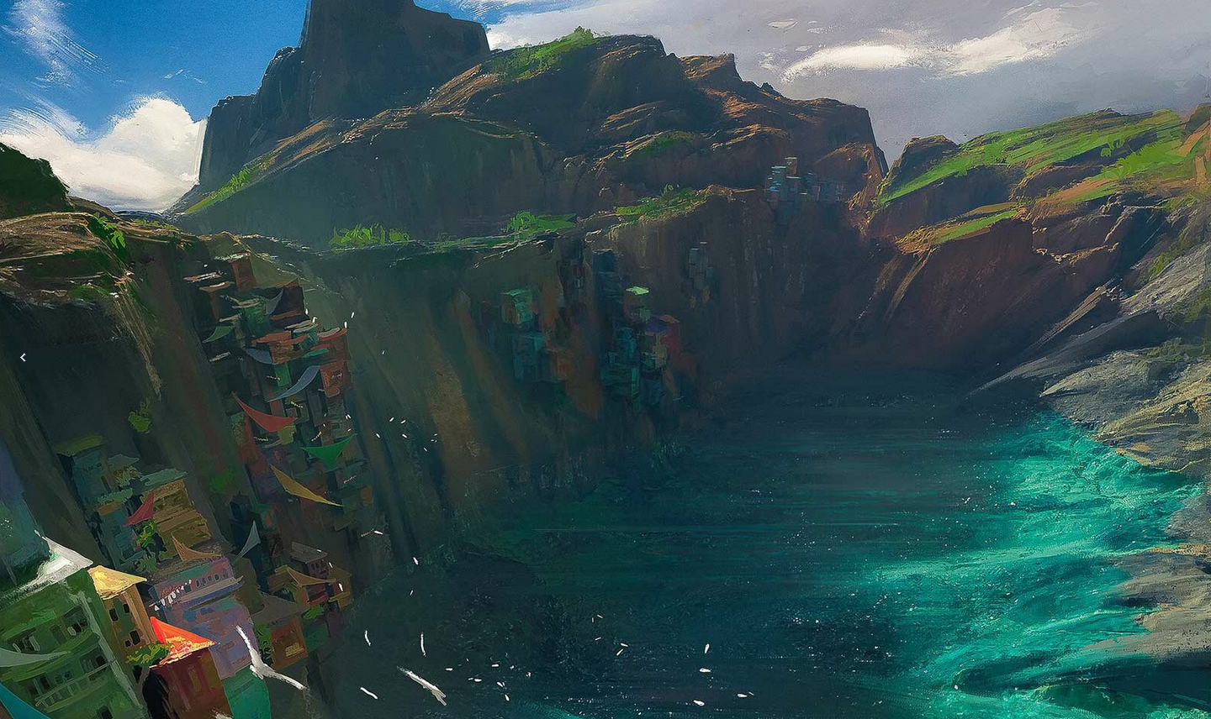

# Working title

Neverwinter Days

# Elevator pitch

We're developing an open-world RPG game set in a medieval fantasy world inspired by European folklore. Its gameplay is strongly story-driven and based on the best-selling book "Earl of the Rings". It's "The Witcher" meets "Dark Souls" meets "Game of Thrones".

# Concept

## Overview

* **Genre:** Open-world RPG / Action
* **Target audience:**
  + **Age:** 15-30
  + **Gender:** Male/Female
  + ...
* **Monetization:** Freemium, with in-game micro-transactions
* **Platforms & system requirements:**
  + ...
  + ...
  + ...

## Theme and setting

Neverwinter Days is a role-playing game set in a historical fantasy version of medieval Europe. The player takes on the role of the Chosen One and gets to explore an open world of 450 square kilometers. While the geographic setting of the game is historically accurate, the game features many supernatural elements.

Learn more about the [Locations](https://app.nuclino.com/t/b/a43248a0-31bb-4573-9125-dfba3a1aaaf9), [Story](https://app.nuclino.com/t/b/c4108852-097f-4b75-9b97-25bbd0983dfb), and [Characters](https://app.nuclino.com/t/b/95f55b54-418f-4e93-beba-d7339c8b58a3) of the game.

...

# Project scope

## Our team

* **Dev:** [@Sonia](https://help.nuclino.com/988f802d-mention-a-team-member), [@Paras](https://help.nuclino.com/988f802d-mention-a-team-member), [@Ruben](https://help.nuclino.com/988f802d-mention-a-team-member)
* **Design:** [@Matt](https://help.nuclino.com/988f802d-mention-a-team-member), [@Antonio](https://help.nuclino.com/988f802d-mention-a-team-member)
* **Art:** [@Erica](https://help.nuclino.com/988f802d-mention-a-team-member)
* **QA:** [@Darren](https://help.nuclino.com/988f802d-mention-a-team-member)
* ... [@Name](https://help.nuclino.com/988f802d-mention-a-team-member)

## Budget

|  |  |
| --- | --- |
| **Spend Type** | **Planned** |
| ... |  |
| ... |  |

## Timeline

* ...
* ...
* ...

*Artwork credit:*[*Stephane Wootha Richard*](https://commons.wikimedia.org/wiki/User:Artofwootha)